|  |
| --- |
| BCIT IOT |
| Telus NB-IOT  Documentation |
| BCIT ARLO & Telus |
|  |
| **Connor Vinchoff**  **Nathan Chung**  **Natalie Doan**  **Kevin Shi**  **Matthew Marty**  **Muhammad Bilal Zubair**  **Cody Chand** |
|  |

# User Manual

**Dashboard**

* Gives an overall summary of all devices activity-level
* You can access any device’s detail page on this page by clicking on it

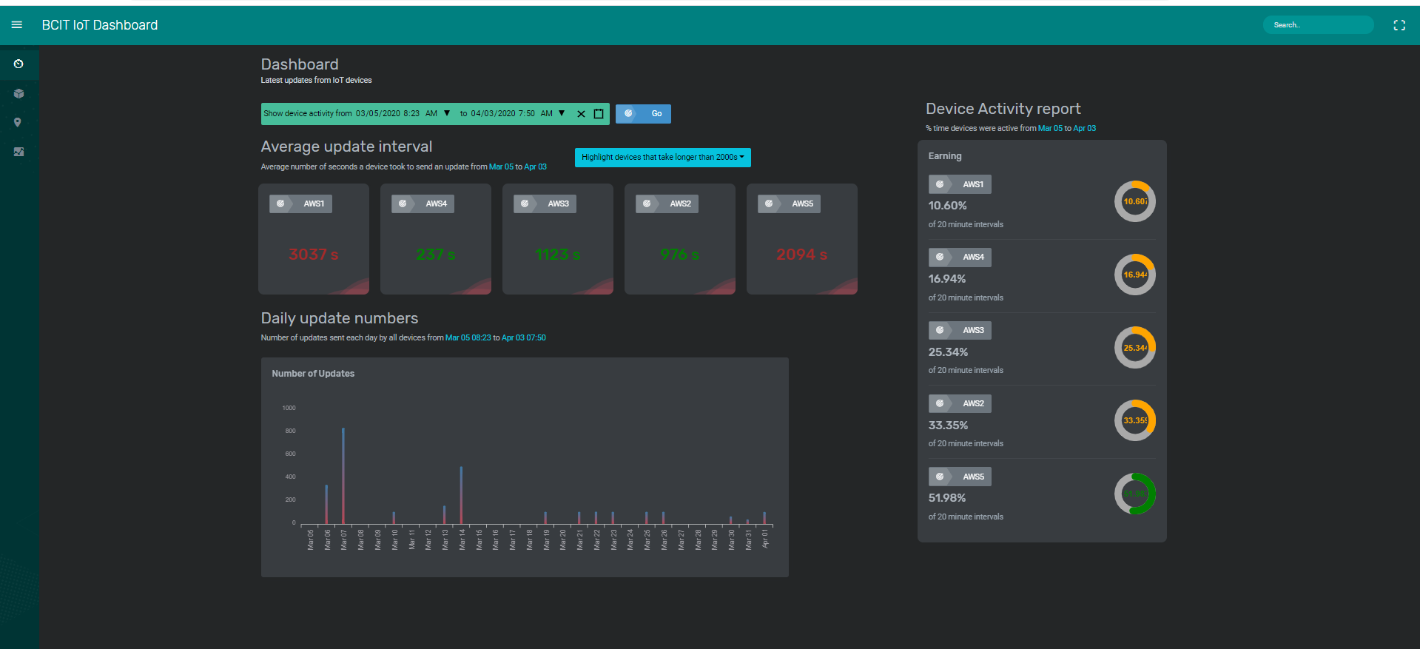

* Date/Time Picker
  + Allows user to either manually input the start date/time and end date/time or select the values from a calendar and clock



* Average Interval Update
  + Lists all devices
  + Drop-down to highlight devices depending on average update time

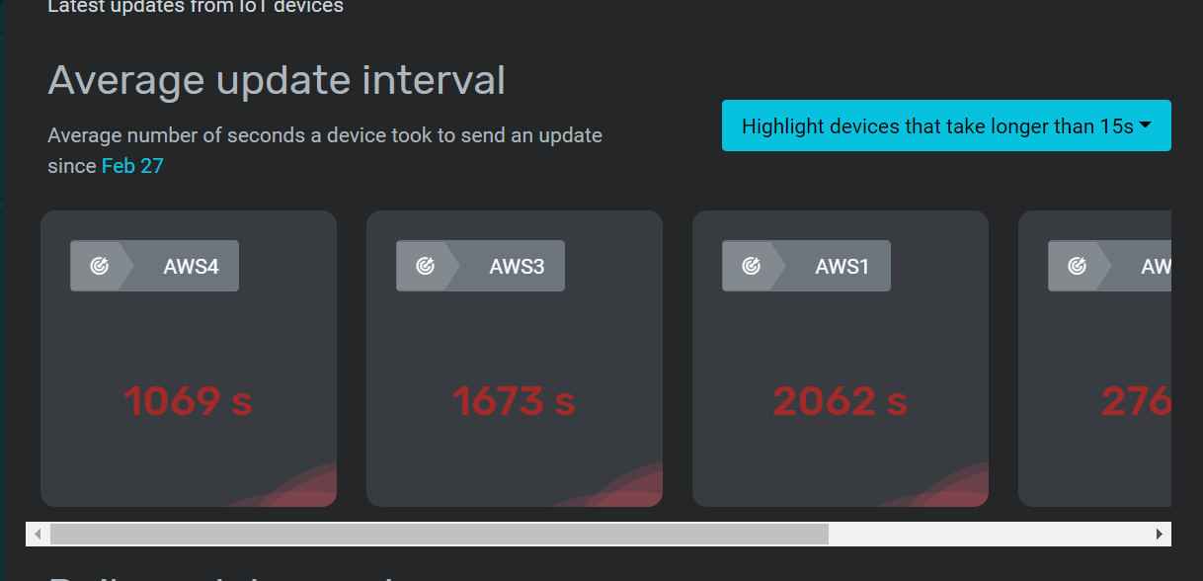

* Device Activity Report
  + Lists all devices
  + Reports how active devices are within a given time-frame

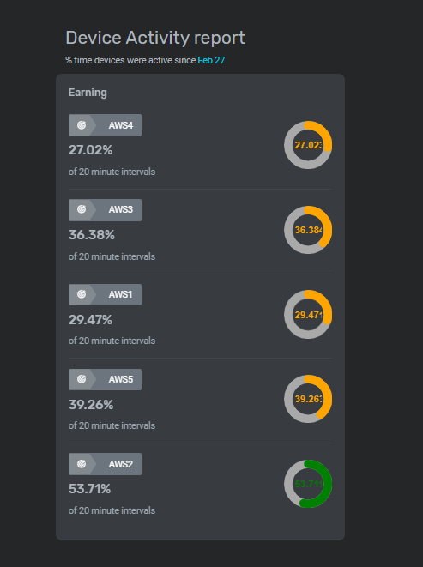

* Daily Update Numbers
  + chart of the number of updates from all devices by day

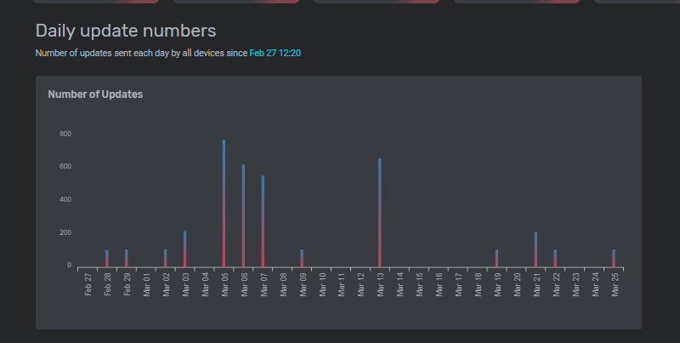

**Devices**

* Page listing all devices, including individual device details

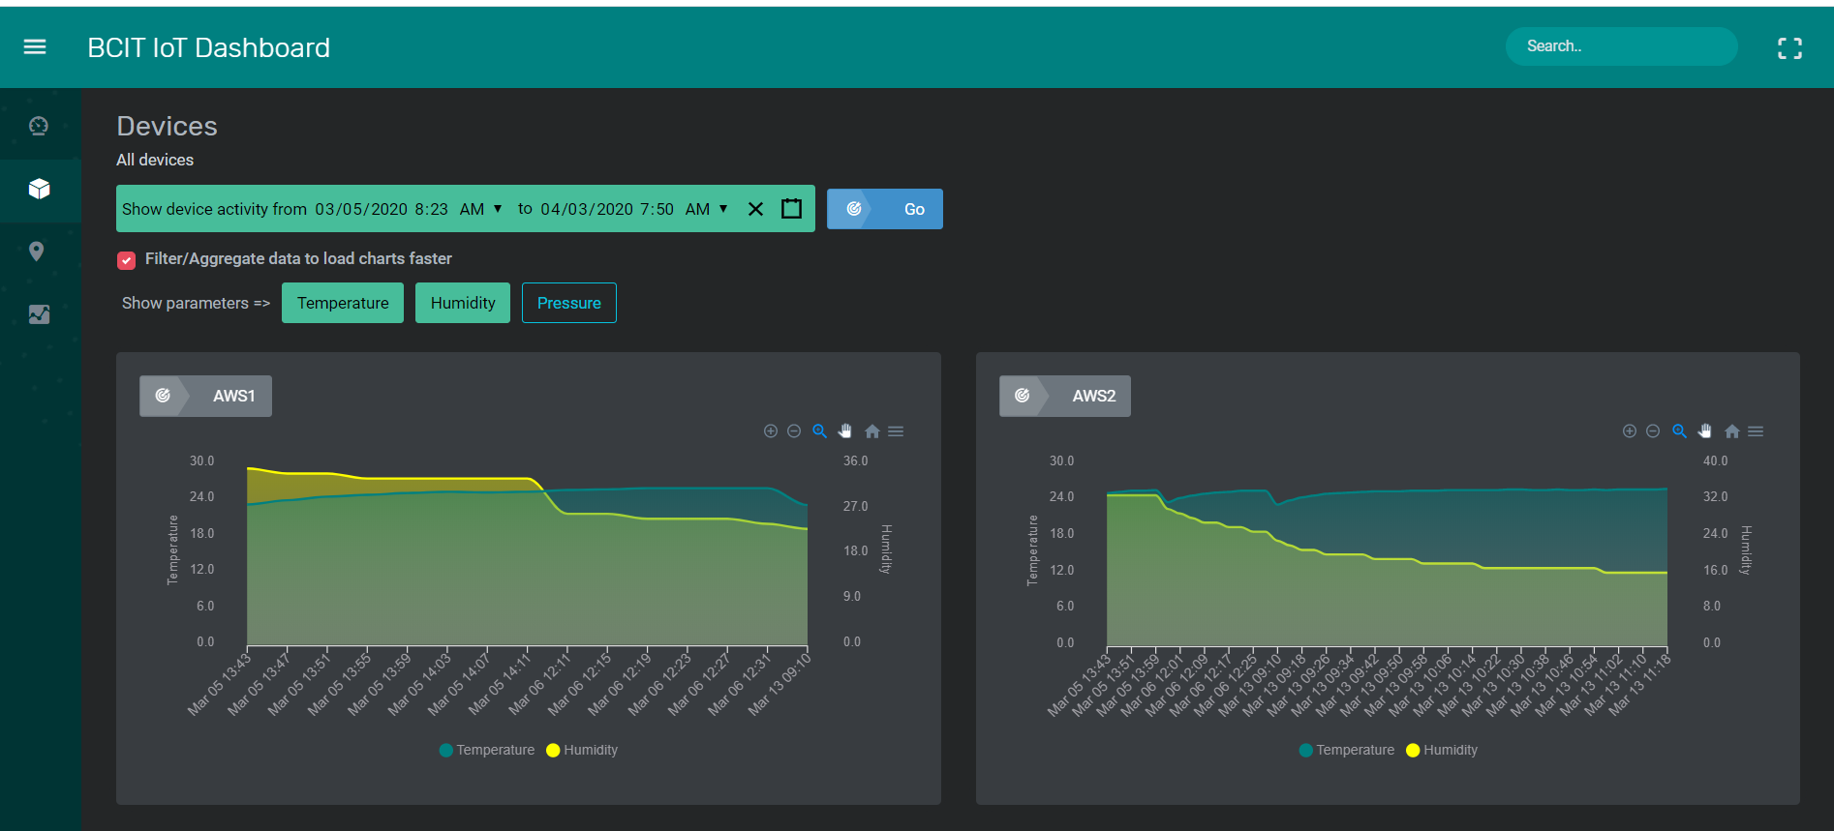

* Date/Time Picker that allows user to either manually input the start date/time and end date/time or select the values from a calendar and clock



* Filter/Aggregate Function Checkbox that allows charts to load faster



* Show Parameters Buttons that allow user to select specific parameters to be displayed on the charts across all devices

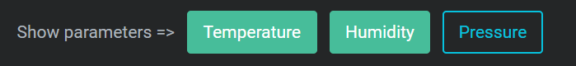

* Charts include:
  + Device name
  + Parameters
  + Zoom options
  + Report downloads

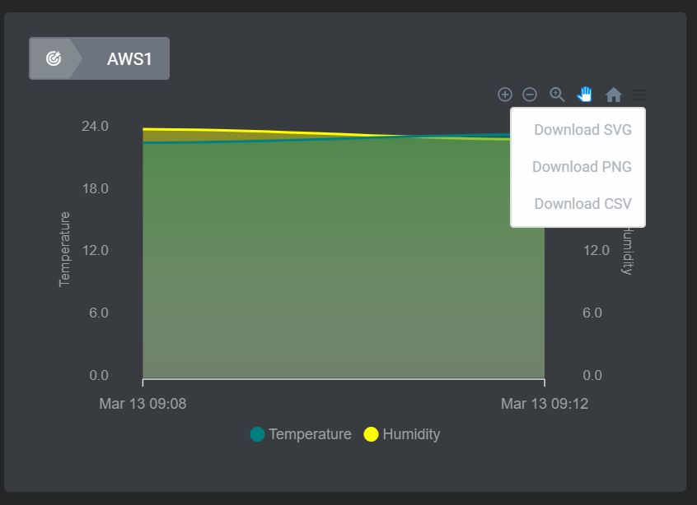

* Clicking on a specific device will bring you the device detail page in which all parameters are represented on their own individual graphs

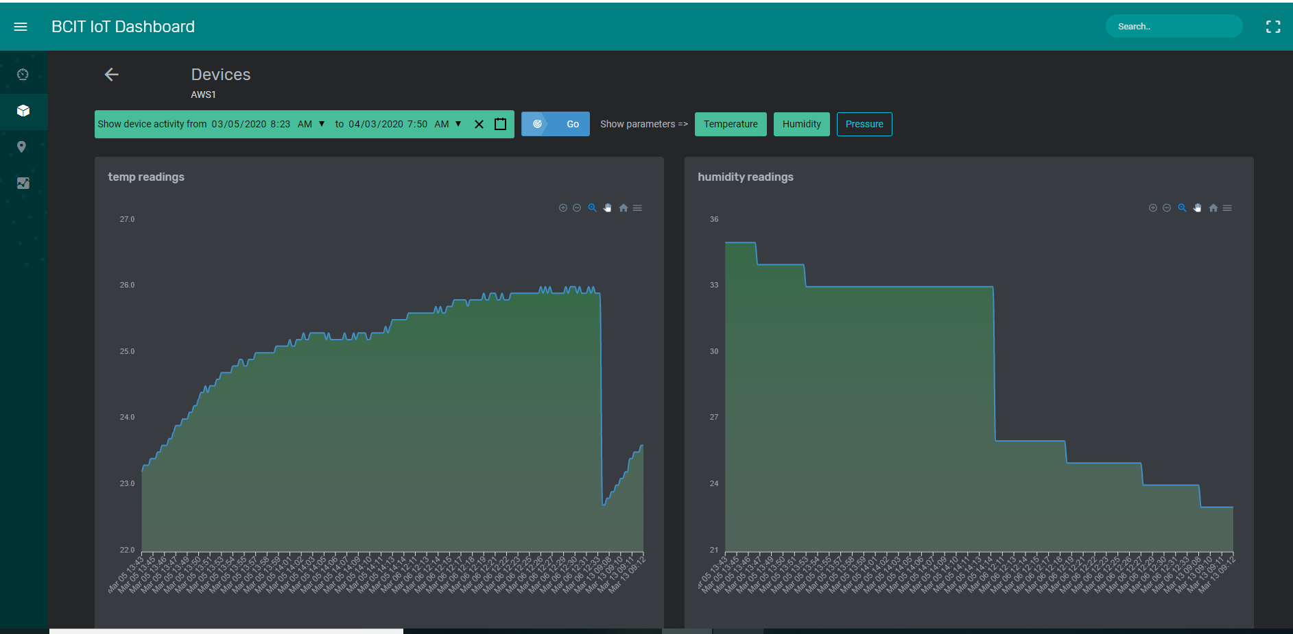

**Locations**

* Floor plans that indicate the location of the devices
* Clicking on the device (red label) will take you to the device’s detail page

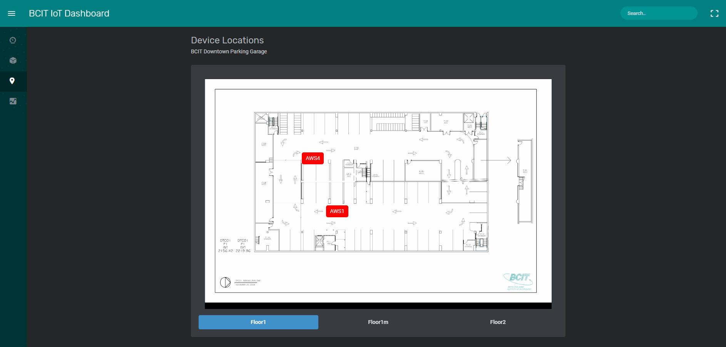

**Parameters**

* Date/Time Picker that allows user to either manually input the start date/time and end date/time or select the values from a calendar and clock



* Filter/Aggregate Function Checkbox that allows charts to load faster



* Individual chart to display one parameter at a time
* Device Toggle to show different devices on chart

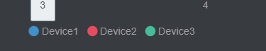

* Parameter tabs to choose which parameter to display

